Principles of Design
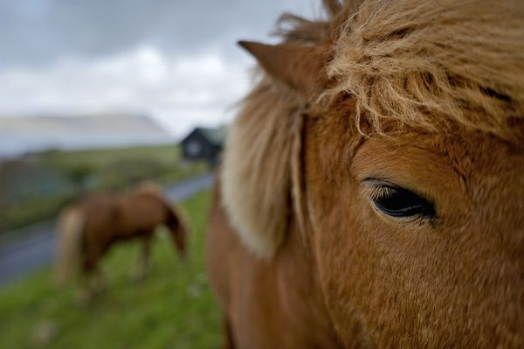
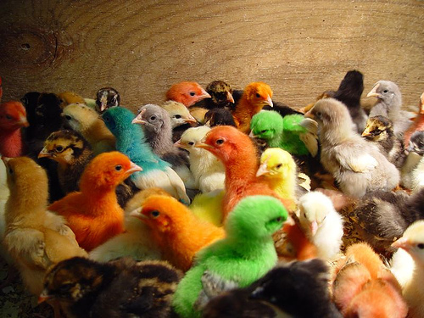
Diversity Dominance

This is an example of diversity within one The presence of the horse so focused and picture, as there are many different places close to the camera draws the eyes to one side of focus where the eyes are drawn. towards the right side of the picture.
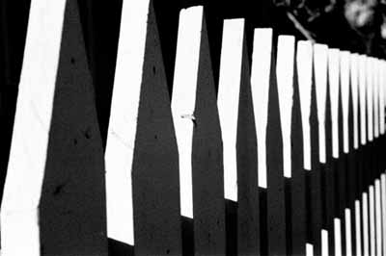
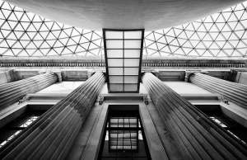
Symmetrical Balance Rhythm

Symmetrical balance is visible in this picture This picture shows rhythm in the repetition due to the everything being mirrored on both of the white picket fence posts, creating a sides of the picture – from the columns to the steady beat in the photograph. window on top.

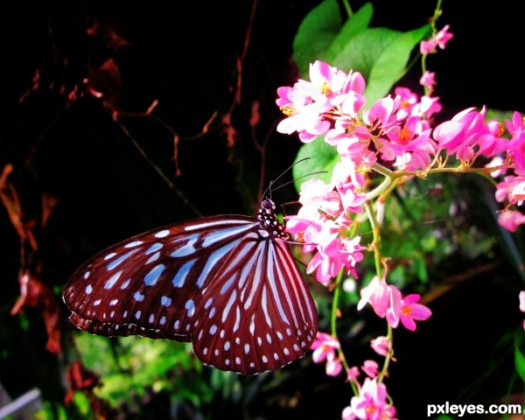
Proportion Harmony

This picture shows harmony within the Proportion is clear in this picture, showing composition, through the balance in the difference in size between the person and objects in the photo and the contrast in the giant rock, all while far away. colours.
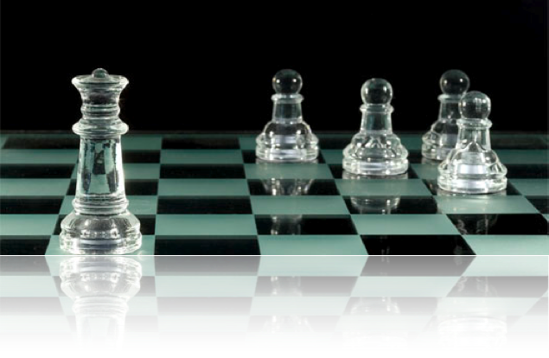
Asymmetrical Balance

This picture shows perfect asymmetrical balance through the chess pieces, as there is harmony pieces, as there is harmony between one large chess piece and four small ones – although they small ones – although they do not look the same, the eye still focuses on both sides of the on on both sides of the picture equally.

