What is Graphic Design?
Graphic Design – Using programs to create appealing media to be used on websites, posters, and entertainment, usually done for a client
Products Possibly Used by Graphic Designers
- Photoshop
- Website creators (eg, Weebly)
- Moviemakers (eg, IMovie)
- Animators (eg, Pivot Stickfigure)
- Virtual Creators (eg, Google Sketchup)
- Audacity
- Scanner
- Social Networking Sites (eg,Facebook)
- Paper and Pen to brainstorm
- USB Key
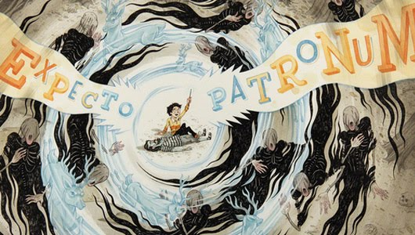

Fig. 1, Graphic design of Harry Potter and the Prisoner of Azkaban

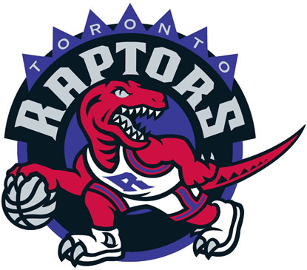
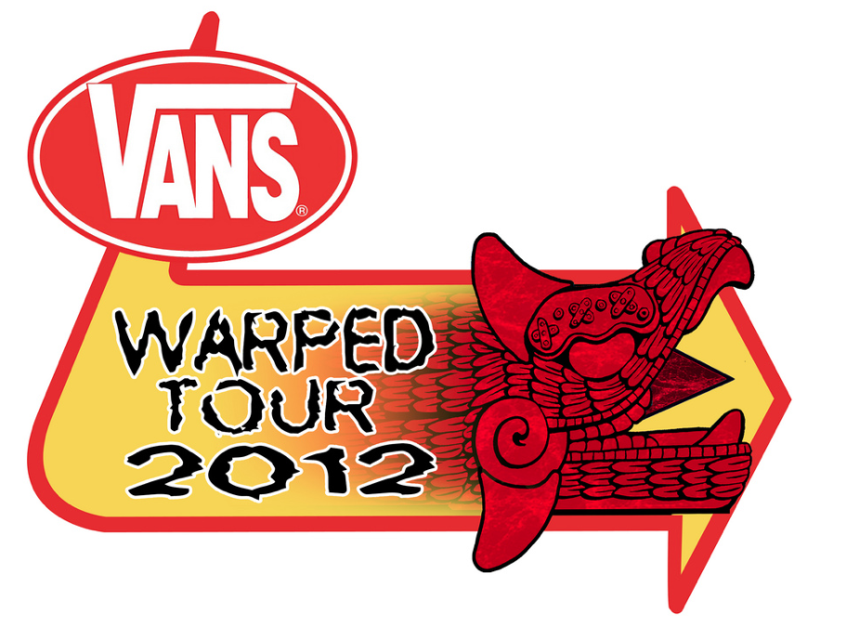

Fig. 2, Toronto Raptors Logo Fig. 3, Vans Warped Tour 2012
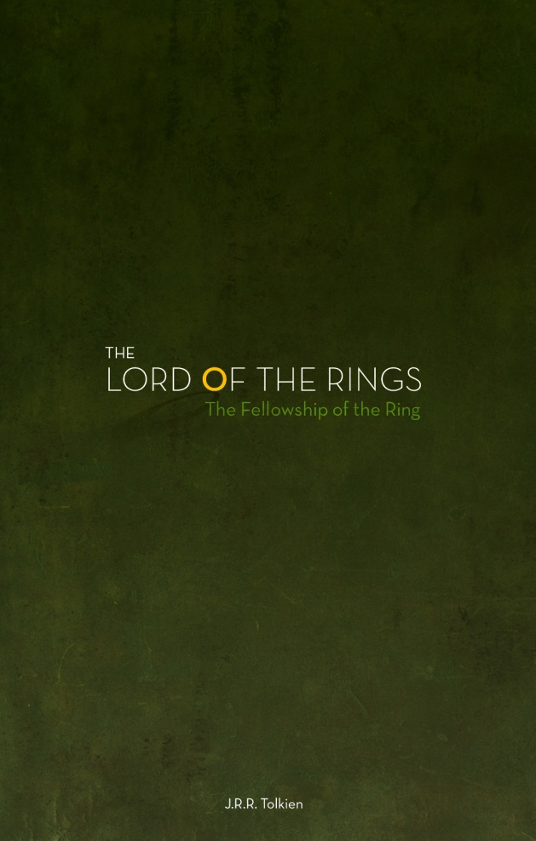
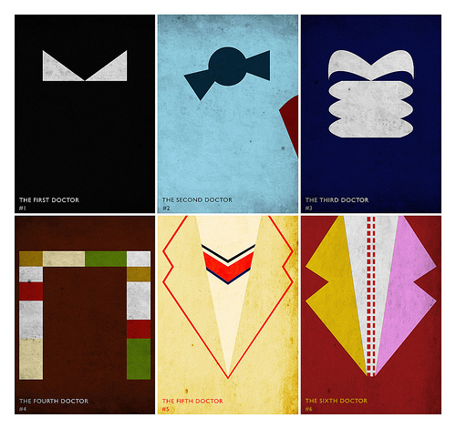

Fig. 4, Lord of the Rings Minimalist Poster Fig. 5, Doctor Who Graphic

Works Cited
http://favim.com/orig/201106/30/art-bbc-doctor-doctor-who-graphic-design-poster-Favim.com-88621.jpg
http://www.creativepanorama.com/wp-content/uploads/2011/03/LOTR_Poster_1.jpg
http://thronebuzz.com/wp-content/uploads/2012/03/Warped-tour-2012-mayan.png
http://www.canadiandesignresource.ca/officialgallery/wp-content/uploads/2009/06/toronto-raptors-original-logo.jpg
http://2.bp.blogspot.com/-bIy3p6-wN24/Tivs2UWnZuI/AAAAAAAACWU/EYR735hXn6Y/s1600/40%2BBeautiful%2BHarry%2BPotter%2BArt%2Band%2BIllustration%2BTributes.jpg

