Elements of Design
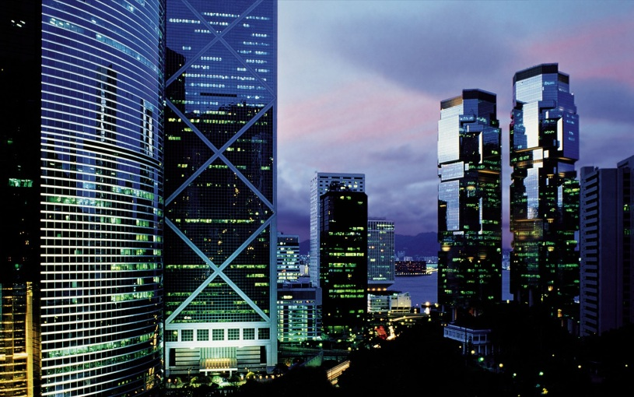
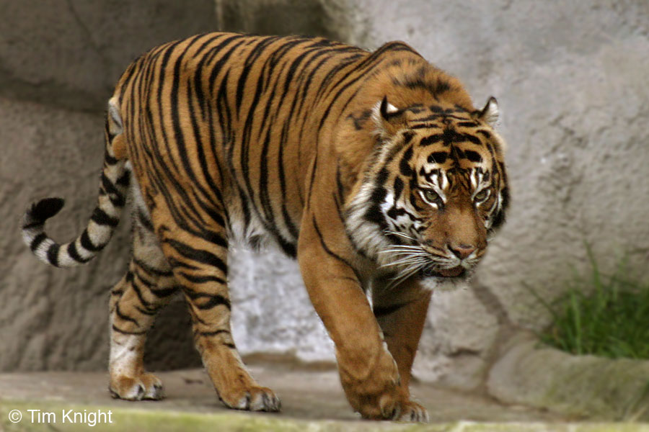
Line Shape

This picture shows clear lines circling the body This picture shows distinct geometric shapes of the tiger in a unique pattern. In the skyscrapers, mostly rectangle designs.
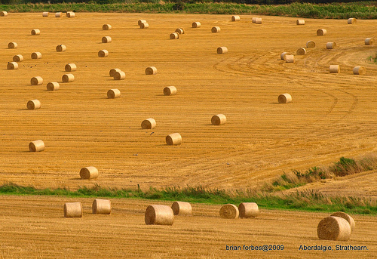
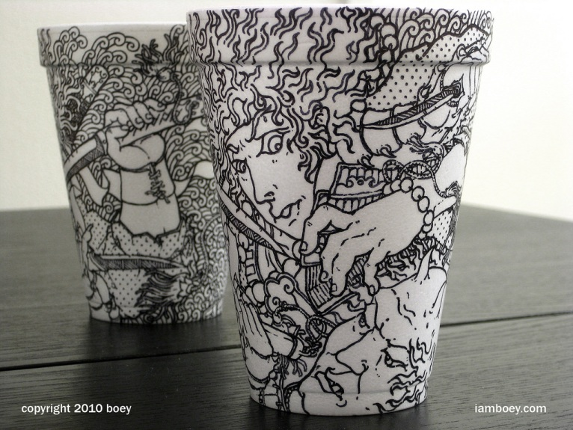
Value Colour

Value is visible in this picture due to the strong This picture showcases colour in the vast contrast in the design on the cup, which makes field, due to the opposite colours of the the design more prominent. field and the grains.

Space

This picture demonstrates the element of space being used because there is positive and negative space, as well as a background and foreground.
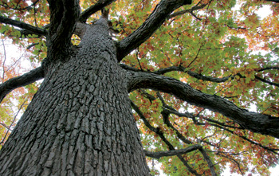
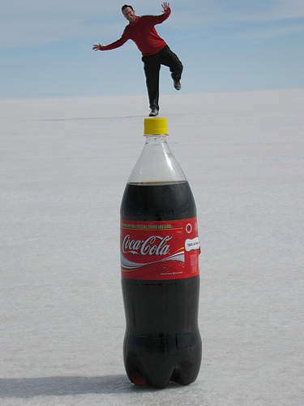
Scale/Size Texture

This picture is showcasing the rough texture of the bark, thus making the image a good example for the element of texture.

This picture uses scaling and sizing to create and an optical illusion, by making the man stand oooooooo back in the sand while placing the bottle in ooo front – thus making it appear as if the man is tiny and standing on the bottle.

